PRESS RELEASE
Solo show-Luis Perez “City Lights”

Exhibition Dates: 2ND -24TH October 2015
Private View: 1st October 2015 6 – 8 p.m.

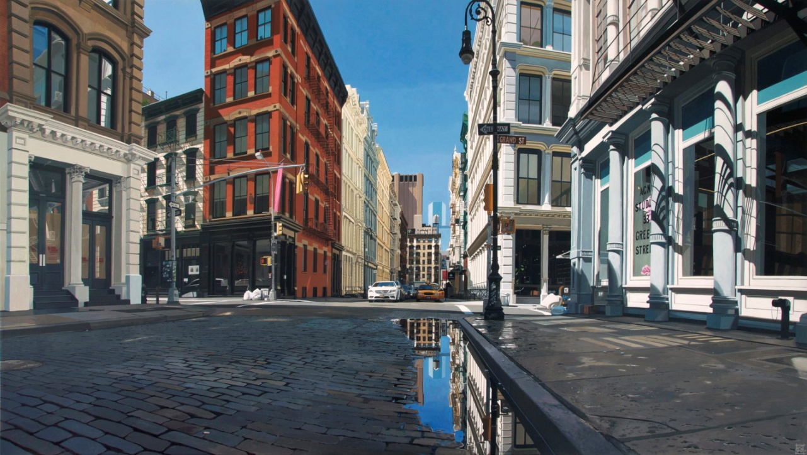

Greene St/Soho II, 70 x 140 cm, Acrylic on Canvas

Plus One Gallery is proud to present “City Light”, a solo show by artist Luis Perez, running from 2nd till 24th October, 2015.
Spanish artist Luis Perez has seen travelling as an essential tool to his work. This travelling allows him to explore and capture the changes of well known cities. Within his works he explores the representation of cities, capturing light on reflective surfaces such as wet pavements, shop windows and especially on cars.

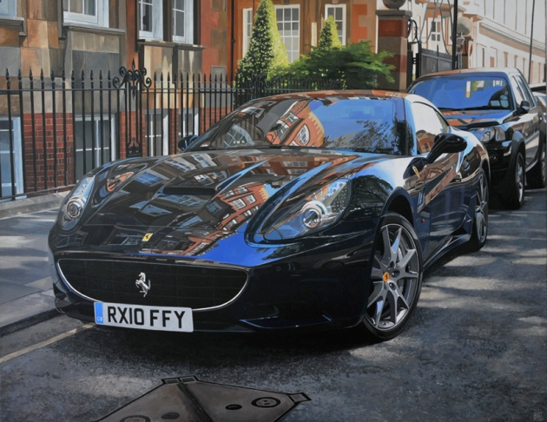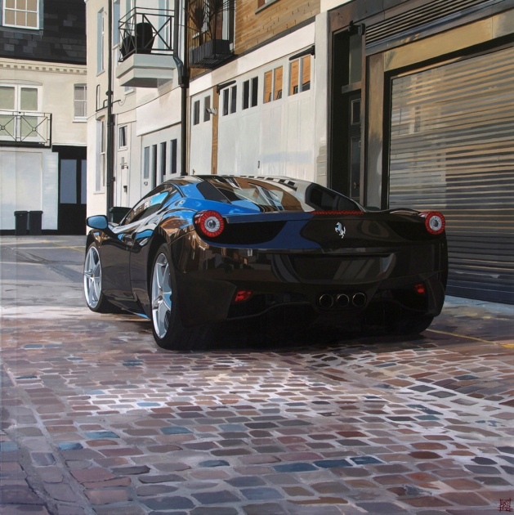

Left: Ferrari California, 114 x 146 cm, Acrylic on Canvas
Right: Queens Gate Place Mews/Ferrari 458, 130 x 130 cm, Acrylic on Canvas

Speaking about his work he says “an important aspect of my work is that I love cars, not only as beautiful and powerful machines but for the reflections their bodies can offer me”.
This exhibition, of both his latest and classic paintings, is an in depth exploration of light. Perez pushes his limits, seeking the hardest and most diverse light conditions and vibrant street scenes, creating a comprehensive study of light including nightscapes, sunsets, sunrises, snow, and rain. For the viewer this means finding still and tranquil moments in busy modern cities

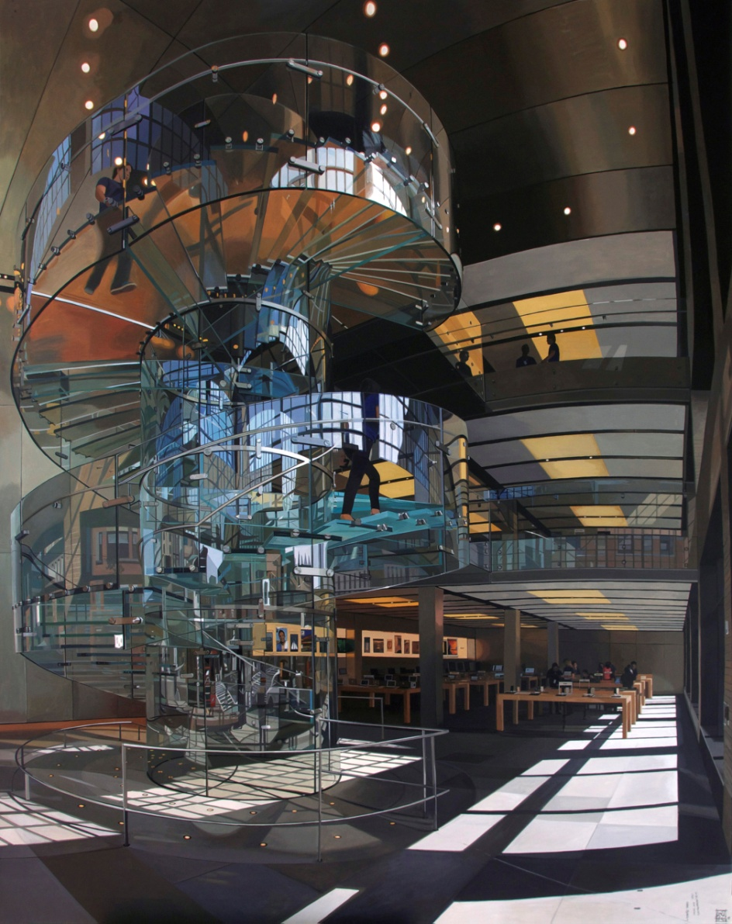
Apple Store Staircase, 146 x 114 cm, Acrylic on Canvas

By freezing images that capture “that special and magical moment” in cities such as London, New York, San Francisco, Tokyo, Paris and Los Angeles, Perez expands the boundaries of the traditional landscape. His metropolitan paintings describe nature’s interaction with the contours of the man-made. They depict a created environment, built around us and created through human engineering. He portrays realities where reality is merely a source of inspiration and he filters it through his own reflected thoughts and feelings.
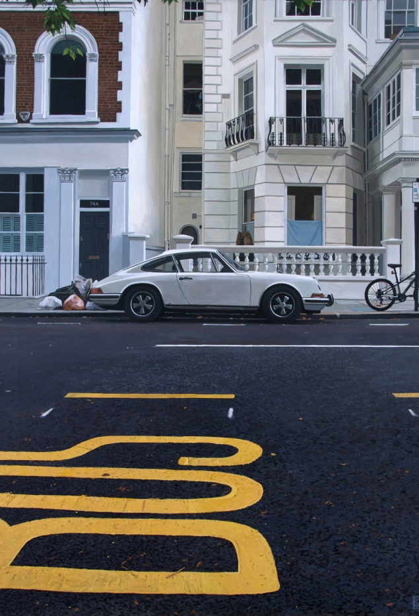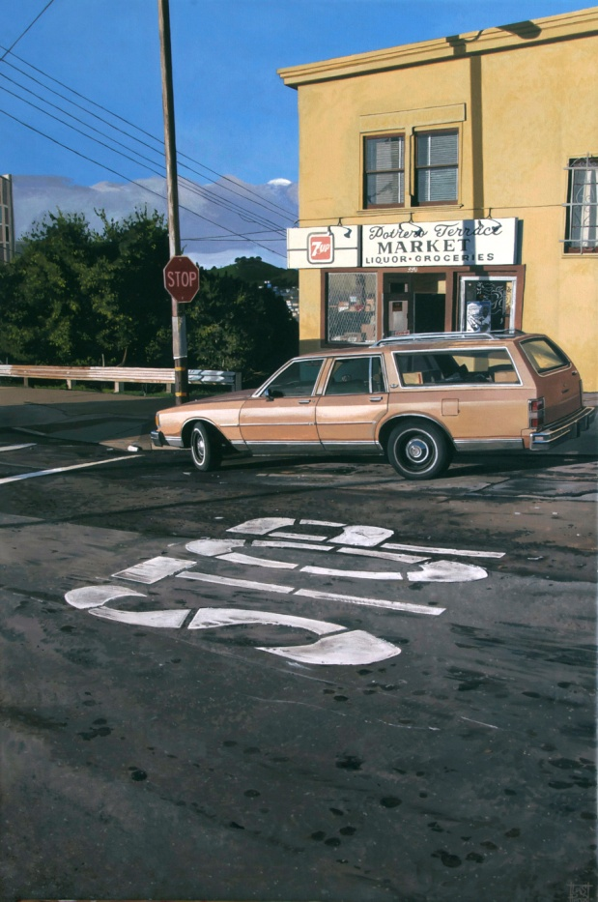
Left: Kensington Park Road/911, 92 x 65 cm, Acrylic on Canvas
Right: Potrero Terrace Market, 92 x 60 cm, Acrylic on Canvas

This show comes after ten years of working together with Plus One Gallery director Maggie Bollaert. It is his first solo show in London, a city he used to call home. A truly special moment.

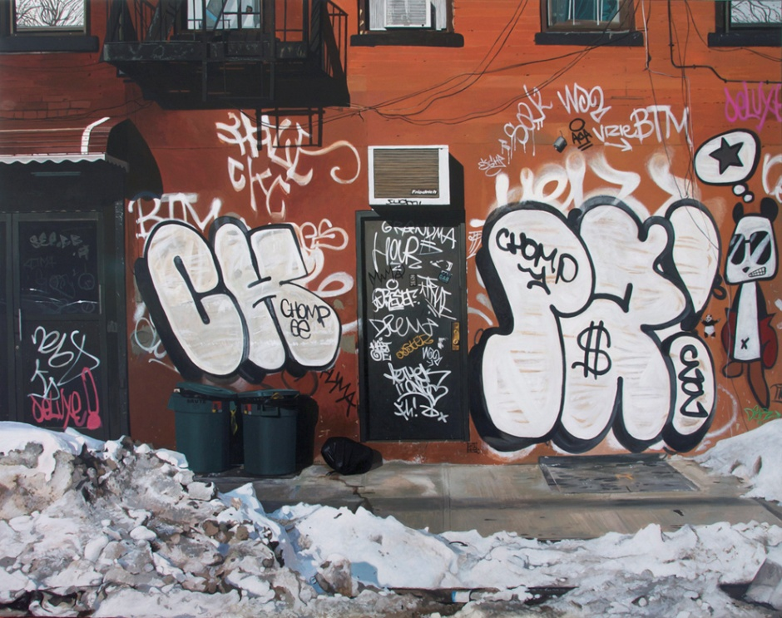
New York City deluxe!, 89 x 116 cm, Acrylic on Canvas

Plus One Gallery
Plus One Gallery is dedicated to the development and promotion of British and international contemporary hyperrealist art. Holding around six exhibitions each year in the main gallery we run an innovative and eclectic exhibition programme, featuring different themes in portrait/human, urban/landscape and still life – the result of which is a wide selection of motifs to suit the most discerning of art collectors.

Plus One Gallery is open to the public Monday to Friday, from 10 a.m. to 6 p.m., Saturday from 10 a.m. to 3 p.m. www.plusonegallery.com

###
For press inquiries, please contact Scarlett Jamieson, scarlett@plusonegallery.com / +44 2077307656
Plus One Gallery
91 Pimlico Road
London
SW1W 8PH

The exhibition can be viewed at www.plusonegallery.com

Follow Plus One Gallery on Facebook (facebook.com/plusonegallery), Twitter (twitter.com/plusonegallery) and Instagram (instagram.com/plusonegallery)

